Ingredients to look out for:
- kanji for wheat (小麦)
- Mizuame, usually written as 水飴 or 水あめ, can contain barley or malt. It is found in many items, especially sweets, but even things you might not expect like sliced ham.
- Some types of vinegar can contain gluten. This is why many people avoid sushi in Japan too. There are many different types of vinegar, but if you see the kanji 酢 (pronounced Su or Zu) it might not be safe.
- A couple more ingredients that are questionable are starch (澱粉 pronounced denpun) and yeast (酵母 pronounced koubo or sometimes as イースト). If you want to err on the side of caution, you might avoid these ingredients.
- Kewpie mayo in Japan contains barley

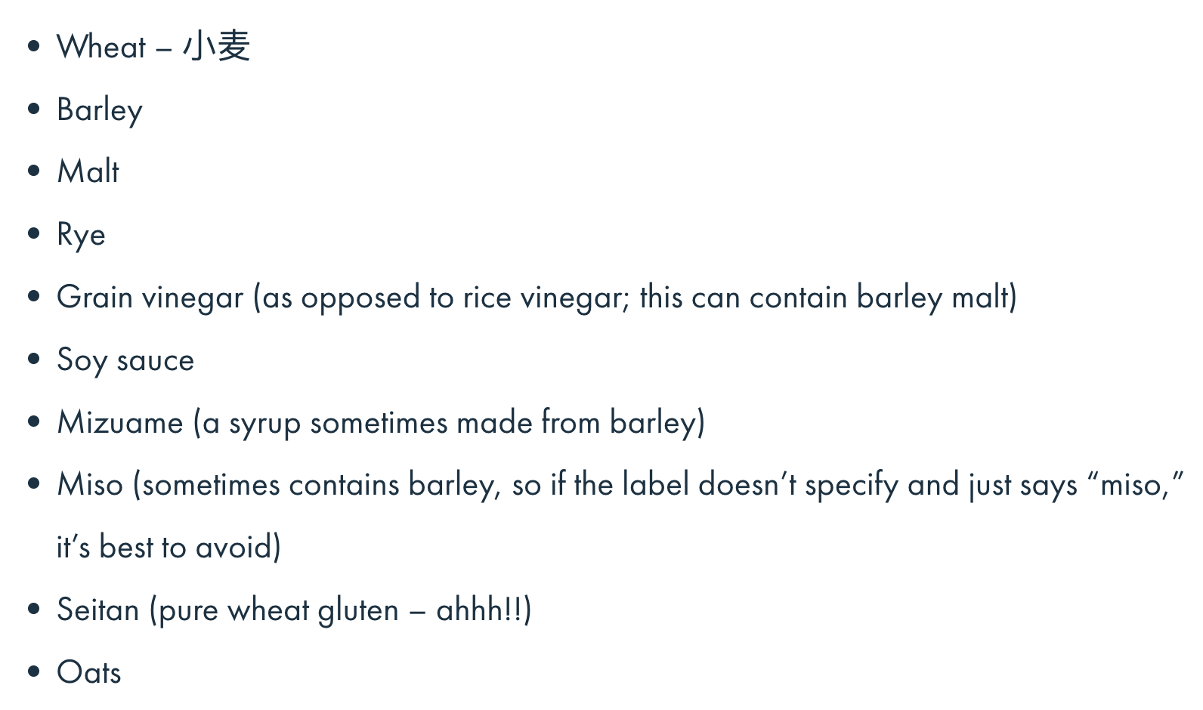

Shops:
Natural Lawson is technically a convenience store, but it’s a fancy one, and you will notice it has a completely different product lineup. They often have GF crackers, ingredients, sweets, but the stock is always changing, so you never know what you’ll find. Some locations even carry gluten-free bread. Unfortunately, there still aren’t so many of these around Japan.

GF at 7-11:
- Soy joy bars
- Boiled Eggs
- Edamame
- Onigiri:
  - Salmon (Family Mart)
  - Red salmon & salt (7-11; this was my personal favorite)
  - Pickled plum (both 7-11 and Family Mart)
- Calbee’s Potato Sticks
- Crunchy potato sticks sold in small tubs. When I visited Japan, the red, green, and blue ones were all GF – as in no gluten ingredients listed on the label and no cross contact warning. I ate them to no ill effect. Not all flavors are GF.
- 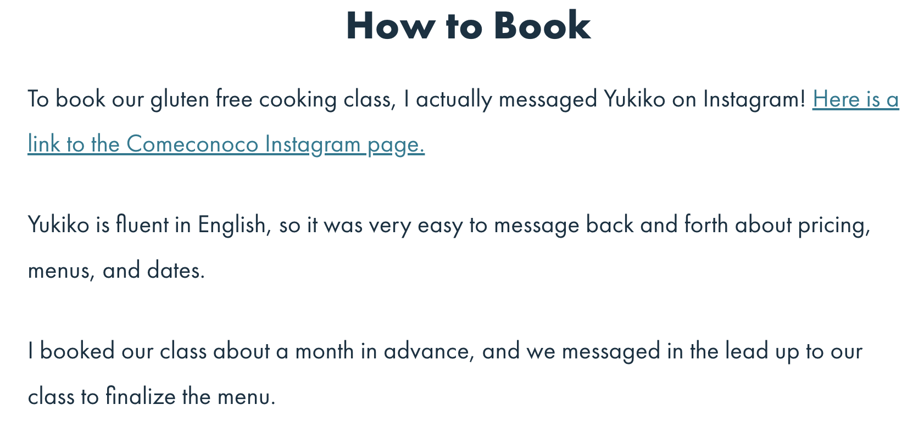
- https://comeconoco.com/

